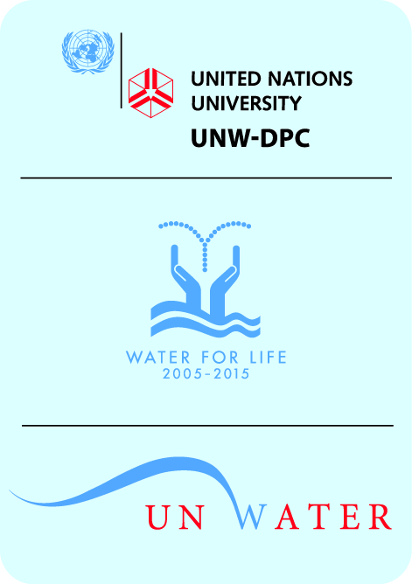
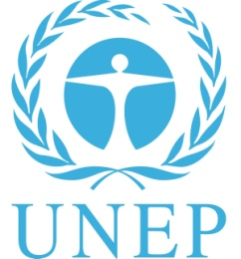
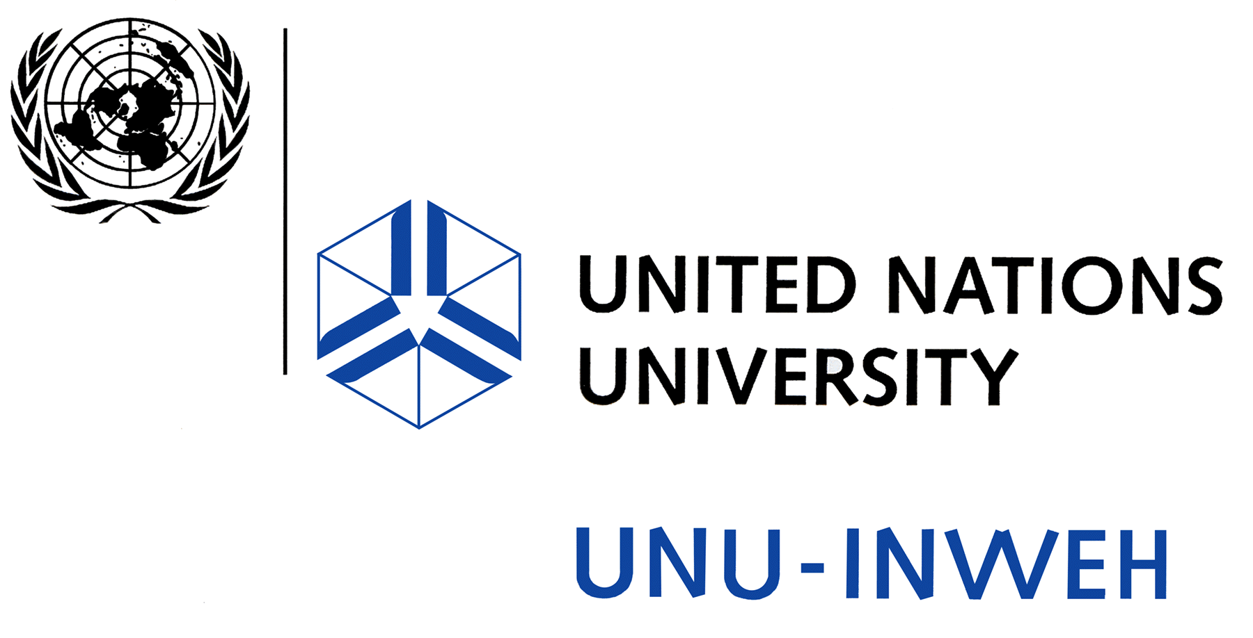
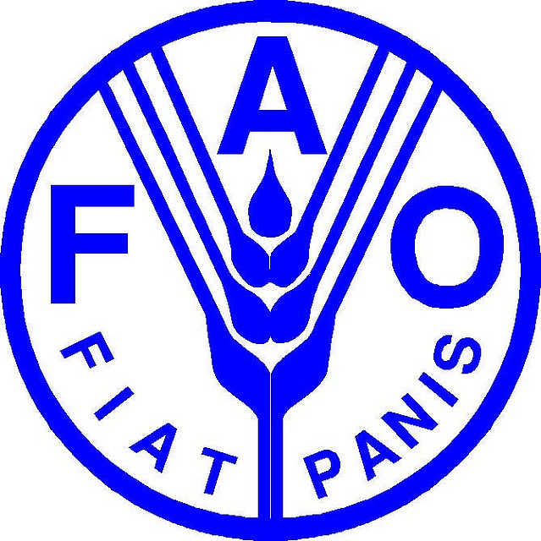

International kick-off workshop
FAO/UNEP/UNU-INWEH/UNW-DPC Capacity Development Project
on Safe Use of Wastewater in Agriculture
UN Campus Bonn, Hermann-Ehlers-Str. 10, 53113 Bonn, Germany
Room 1916

Agenda

November 14, 2011
8:30-9:00 Arrival and Registration
9:00-9:45 Welcome and opening
Introduction of organizing programmes and Agenda
9:45-10:00 Introduction by FAO on its water quality programme (Javier Mateo-Sagasta),
including overview and objectives of “Safe Use of Wastewater in Agriculture” Capacity Development Project
10:00-10:15 Introduction by UNU-INWEH on its programme (Manzoor Qadir), including
differences between direct, indirect, planned or unplanned wastewater use, and environmental impact assessment of wastewater irrigation
10:15-10:30 Introduction by UNW-DPC on its programme (Jens Liebe), including
basic concepts of capacity development (Individual, Organizational, System Level) and presentation of the project agenda/roadmap and structure of the kick-off workshop
10:30-11:00 Coffee break and group photo
Presentations of additional participating UN organizations
11:00-11:15 Introduction by the United Nations Environment Programme (UNEP) on its wastewater programme including its linkages to pro-poor wastewater management (Heidi Savelli)
11:15-11:30 Review of the structure of the questionnaires, based on the main components of the WHO/FAO/UNEP guidelines (Javier Mateo-Sagasta)

Launch of the UN-Water Activity Information System (UNW-AIS+)
11:30-12:15 Launch of AIS+ with Zafar Adeel, UN-Water Chair, and Dirk Jaeger, UNW-DPC

12:15-13:30 Lunch break

Regional panel presentations of Capacity Needs Assessment (CNA) Results
13:30-14:30 Panel on questionnaire results in Region 1: Asia
(moderated by Manzoor Qadir, UNU-INWEH)
India, Iran, Jordan, Lebanon, Pakistan, and Syria
14:30-15:15 Panel on questionnaire results in Region 2: Latin America
(moderated by Javier Mateo-Sagasta, FAO)
Bolivia, Colombia, Guatemala, and Peru
15:15-15:30 Coffee break
15:30-16:15 Panel on questionnaire results in Region 3a: Northern Africa
(moderated by Jens Liebe, UNW-DPC)
Algeria, Egypt, Morocco, and Tunisia
16:15-16:45 Panel on questionnaire results in Region 3b: Sub-Saharan Africa
(moderated by Heidi Savelli, UNEP)
Ghana, Senegal, and South Africa
16:45-17:30 Synopsis of regional presentations, discussion on regional and overarching issues
(Richard Thomas, UNU-INWEH)

November 15, 2011
Recap of day 1 and Introduction of additional materials
9:00-9:15 Recap of day 1, agenda for the day (UNW-DPC)
9:15-9:30 Presentation of existing FAO materials (Javier Mateo-Sagasta, FAO)
- FAO Water Report 35: The Wealth of Waste: The economics of wastewater use in agriculture.
- Farm field school manuals on safe wastewater use in agriculture
- Wastewater accounting (AQUASTAT)
Presentations by Guest Organizations
9:30-10:00 Presentation by the German Water Association (DWA)’s Working Group on Water
Re-use
10:00-10:25 Presentation by the International Water Management Institute, IWMI: Testing the WHO guidelines: Risk assessment and mitigation where wastewater treatment fails
(presented by Manzoor Qadir, UNU-INWEH)
10:25-10:45 Coffee break
10:45-12:30 Discussion on the way forward, the purpose of the regional workshops, discussion of outcomes of the first day’s regional panels overall suggestions, and conditions for successful data collection (moderated by Reza Ardakanian, UNW-DPC)
12:30-13:30 Lunch break
13:30-15:30 Regional break out groups to discuss the information needs of countries engaging in safe use of wastewater in agriculture, support from UN agencies, and involvement of other organizations in the regional workshops
Africa Group, Room 1916 (with Heidi Savelli, UNEP & Jens Liebe, UNW-DPC)
Asia Group, Room 1605 (with Manzoor Qadir, UNU-INWEH)
Latin America Group, Room 1625 (with Javier Mateo-Sagasta, FAO)
15:30-15:45 Coffee break
15:45-16:15 Report of the speakers of the three Regional breakout groups
16:15-17:30 Synopsis, Formulation of a kick-off workshop statement, decision on follow-up workshops, and workshop closing remarks
(moderated by Manzoor Qadir, UNU-INWEH)
18:00-20:00 Bonn Dialogue on “The Water, Energy and Food Security Nexus: Solutions for the Green Economy,” the only public symposium of the Bonn2011 Nexus Conference. Reception to follow.

